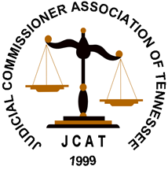

Registration is open to all Judicial Commissioners in Tennessee. The conference and accommodations will be at the Drury Inn 1874 W McEwen Drive, Franklin TN 37064.
Hotel reservations are available by calling 1-800-325-0720 and referring to group number 10156557.
Ask to make a reservation in the “Judicial Commissioners Association of TN” room block.
Please do not use Third Party Apps when making reservations.
Please make your own conference and room reservations. JCAT WILL NOT complete your registration for Conference.
Questions: contact jcatsecretary@outlook.com
2025 Summer Conference Franklin, TN
April 22nd, 23rd, 24th, 2026
Williamson County

You may arrive on Tuesday, April 21st. Tuesday is a travel day and will be paid by JCAT

Franklin Conference will fill up quickly so don’t delay in registering.
Conference and Room accommodation deadline is March 20, 2026 or when registration is Full

